Exercise - 11

Write HTML code to create a web page with heading. The heading shall be displayed at the top-center of the page and the image shall be at the centre, just below the heading.

Code:

<!DOCTYPE html>

<html lang="en">

<head>

<meta charset="UTF-8">

<meta name="viewport" content="width=device-width, initial-scale=1.0">

<title>Top Heading and Centered Image</title>

<style>

body {

display: flex;

flex-direction: column;

align-items: center;

margin: 0;

font-family: Arial, sans-serif;

height: 100vh;

}

h1 {

text-align: center;

margin-top: 20px;

}

.image-container {

display: flex;

flex-grow: 1;

align-items: center;

justify-content: center;

width: 100%;

}

img {

max-width: 100%;

height: auto;

}

</style>

</head>

<body

<h1>Top-Centered Heading</h1>

<div class="image-container">

<img src="C:\Users\Mayank\OneDrive\Desktop\images.jpg" alt="Centered Image">

</div>

</body>

</html>

Output:

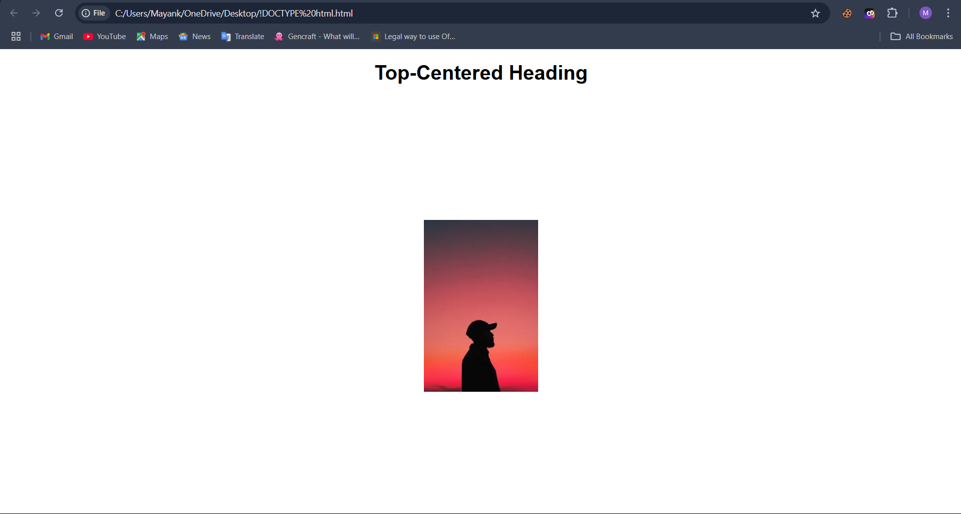

Exercise - 12

Write HTML code using Multimedia tags.

Code:

<!DOCTYPE html>

<html lang="en">

<head>

<meta charset="UTF-8">

<title>Simple Multimedia Example</title>

</head>

<body>

<h1>Simple Multimedia Tags</h1>

<h2>Audio</h2>

<audio controls>

<source src="audio.mp3" type="audio/mpeg">

Your browser does not support the audio element.

</audio>

<h2>Video</h2>

<video controls width="320">

<source src="video.mp4" type="video/mp4">

Your browser does not support the video element.

</video>

<h2>YouTube Video</h2>

<iframe width="560" height="315" src="https://www.youtube.com/embed/example"

allowfullscreen>

</iframe>

</body>

</html>

Output:

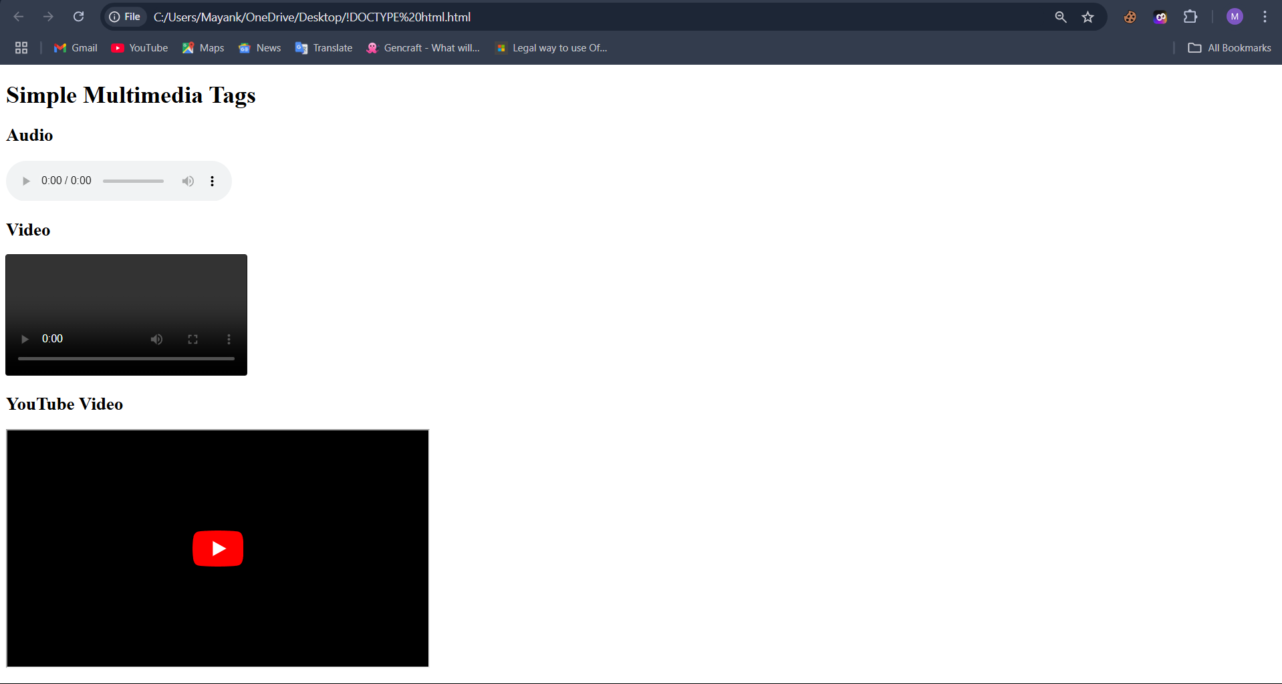

Exercise - 13

Create a Table using Rowspan and Colspan taking example of student Record.

Code:

<!DOCTYPE html>

<html lang="en">

<head>

<meta charset="UTF-8">

<title>Student Record Table</title>

</head>

<body>

<h1>Student Record</h1>

<table border="1" cellpadding="8" cellspacing="0">

<tr>

<th rowspan="2">Student ID</th>

<th rowspan="2">Name</th>

<th colspan="3">Subjects</th>

<th rowspan="2">Total Marks</th>

</tr>

<tr>

<th>Math</th>

<th>Science</th>

<th>English</th>

</tr>

<tr>

<td rowspan="2">001</td>

<td rowspan="2">Alice</td>

<td>85</td>

<td>78</td>

<td>92</td>

<td rowspan="2">255</td>

</tr>

<tr>

<td>90</td>

<td>88</td>

<td>80</td>

</tr>

<tr>

<td rowspan="2">002</td>

<td rowspan="2">Bob</td>

<td>75</td>

<td>82</td>

<td>89</td>

<td rowspan="2">246</td>

</tr>

<tr>

<td>88</td>

<td>76</td>

<td>82</td>

</tr>

</table>

</body>

</html>

Output:

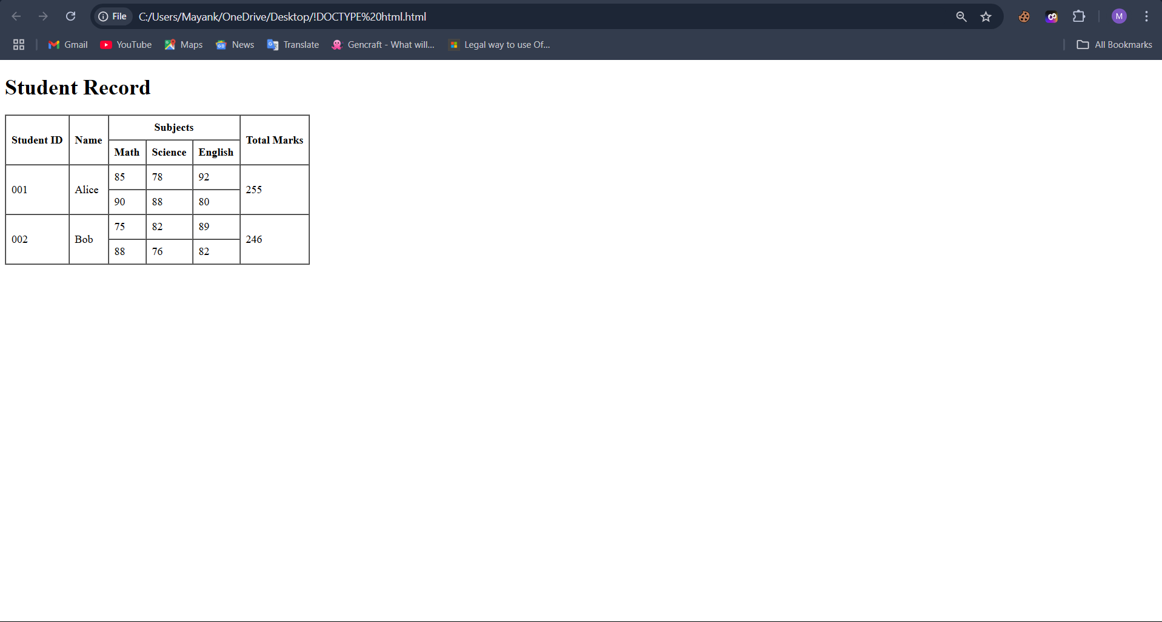

Exercise - 14

Write HTML code using table tag <table> and cellpadding and cell spacing as its attributes.

Code:

<!DOCTYPE html>

<html lang="en">

<head>

<meta charset="UTF-8">

<title>Student Records Table</title>

</head>

<body>

<h1>Student Records</h1>

<table border="1" cellpadding="10" cellspacing="5">

<tr>

<th>Student ID</th>

<th>Name</th>

<th>Grade</th>

</tr>

<tr>

<td>001</td>

<td>Alice</td>

<td>A</td>

</tr>

<tr>

<td>002</td>

<td>Bob</td>

<td>B</td>

</tr>

<tr>

<td>003</td>

<td>Charlie</td>

<td>A</td>

</tr>

</table>

</body>

</html>

Output:

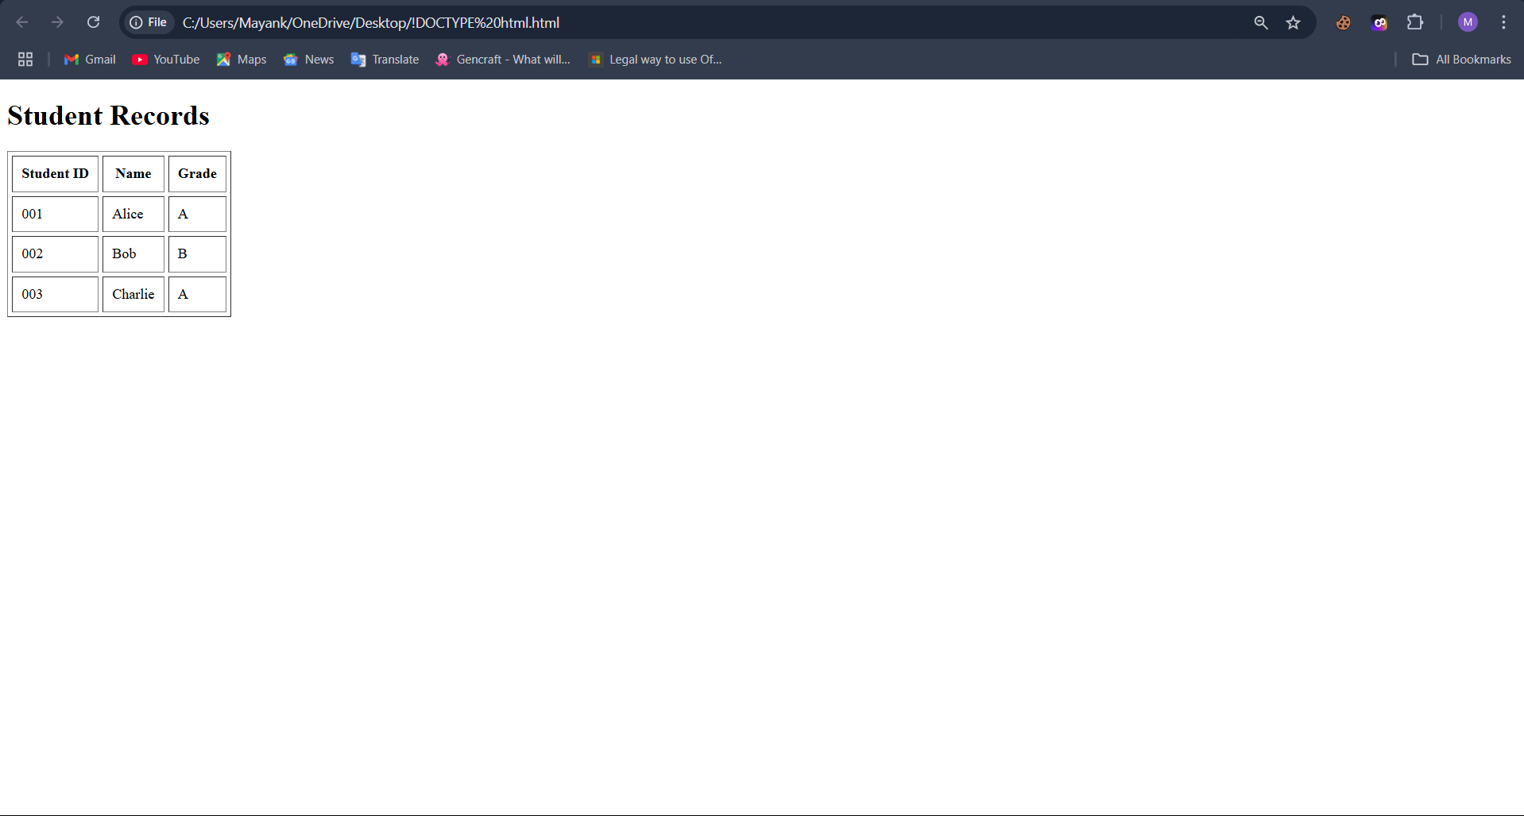

Exercise – 15

Create unordered, ordered and definition Lists taking example of your subjects in MCA IST, IInd and IIIrd Semester.

Code:

<!DOCTYPE html>

<html lang="en">

<head>

<meta charset="UTF-8">

<title>MCA Semester Subjects</title>

</head>

<body>

<h1>MCA Subjects</h1>

<h2>First Semester (IST) Subjects</h2>

<ul>

<li>Mathematics-I</li>

<li>Computer Programming</li>

<li>Digital Logic Design</li>

<li>Communication Skills</li>

<li>Computer Organization</li>

</ul>

<h2>Second Semester (IInd) Subjects</h2>

<ol>

<li>Mathematics-II</li>

<li>Data Structures</li>

<li>Operating Systems</li>

<li>Database Management Systems</li>

<li>Software Engineering</li>

</ol>

<h2>Third Semester (IIIrd) Subjects</h2>

<dl>

<dt>Design and Analysis of Algorithms</dt>

<dd>Study of algorithm efficiency and optimization techniques.</dd>

<br>

<dt>Computer Networks</dt>

<dd>Understanding of network protocols, data communication, and security.</dd>

<br>

<dt>Object-Oriented Programming</dt>

<dd>Principles of object-oriented programming with languages like Java or C++.</dd>

<br>

<dt>Web Technologies</dt>

<dd>Learning technologies used in web development like HTML, CSS, JavaScript, etc.</dd>

<br>

<dt>Management Information Systems</dt>

<dd>Focus on systems used for managing organizations' information.</dd>

</dl>

</body>

</html>

Output:

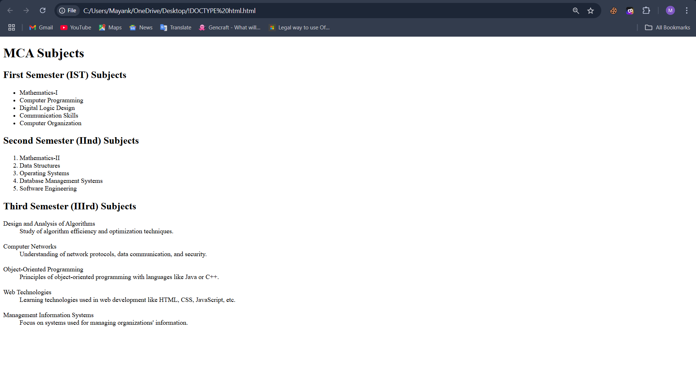

Exercise – 17 , 18 , 19 &24

Write HTML code to design a form in HTML using controls and buttons such as Textbox, Text area, password, submit button, browse button, drop-down menu

Write HTML code to design a Registration Form in HTML.

Write HTML code to design a student admission Form in HTML.

Write code to show External CSS with HTML code

HTML Code:

<!DOCTYPE html>

<html lang="en">

<head>

<meta charset="UTF-8">

<meta name="viewport" content="width=device-width, initial-scale=1.0">

<title>Student Admission Form</title>

<link rel="stylesheet" href="styles.css"> <!-- Linking the external CSS file -->

</head>

<body>

<div class="container">

<h2>Student Admission Form</h2>

<form action="#" method="post">

<h3>Personal Information</h3>

<label for="fullname">Full Name</label>

<input type="text" id="fullname" name="fullname" placeholder="Enter your full name" required>

<label for="dob">Date of Birth</label>

<input type="date" id="dob" name="dob" required>

<label for="gender">Gender</label>

<select id="gender" name="gender" required>

<option value="">Select Gender</option>

<option value="male">Male</option>

<option value="female">Female</option>

<option value="other">Other</option>

</select>

<label for="nationality">Nationality</label>

<input type="text" id="nationality" name="nationality" placeholder="Enter your nationality" required>

<h3>Contact Information</h3>

<label for="email">Email Address</label>

<input type="email" id="email" name="email" placeholder="Enter your email address" required>

<label for="phone">Phone Number</label>

<input type="number" id="phone" name="phone" placeholder="Enter your phone number" required>

<label for="address">Address</label>

<textarea id="address" name="address" rows="4" placeholder="Enter your address" required></textarea>

<h3>Admission Details</h3>

<label for="course">Course Applied For</label>

<select id="course" name="course" required>

<option value="">Select Course</option>

<option value="bachelor">Bachelor of Science</option>

<option value="master">Master of Computer Applications</option>

<option value="phd">PhD in Physics</option>

</select>

<label for="previousqualification">Previous Qualification</label>

<input type="text" id="previousqualification" name="previousqualification" placeholder="Enter your last qualification" required>

<input type="submit" value="Submit Admission">

</form>

</div>

</body>

</html>

CSS Code:

body {

font-family: Arial, sans-serif;

background-color: #f4f4f4;

margin: 0;

padding: 0;

}

.container {

width: 60%;

margin: 30px auto;

background-color: white;

padding: 20px;

border-radius: 8px;

box-shadow: 0 0 10px rgba(0, 0, 0, 0.1);

}

h2 {

text-align: center;

color: #333;

}

label {

display: block;

margin: 10px 0 5px;

}

input[type="text"], input[type="email"], input[type="number"], input[type="date"], select, textarea {

width: 100%;

padding: 10px;

margin-bottom: 10px;

border: 1px solid #ccc;

border-radius: 5px;

}

input[type="submit"] {

background-color: #4CAF50;

color: white;

padding: 10px 20px;

border: none;

border-radius: 5px;

cursor: pointer;

width: 100%;

}

input[type="submit"]:hover {

background-color: #45a049;

}

textarea {

resize: vertical;

padding: 10px;

}

Output:

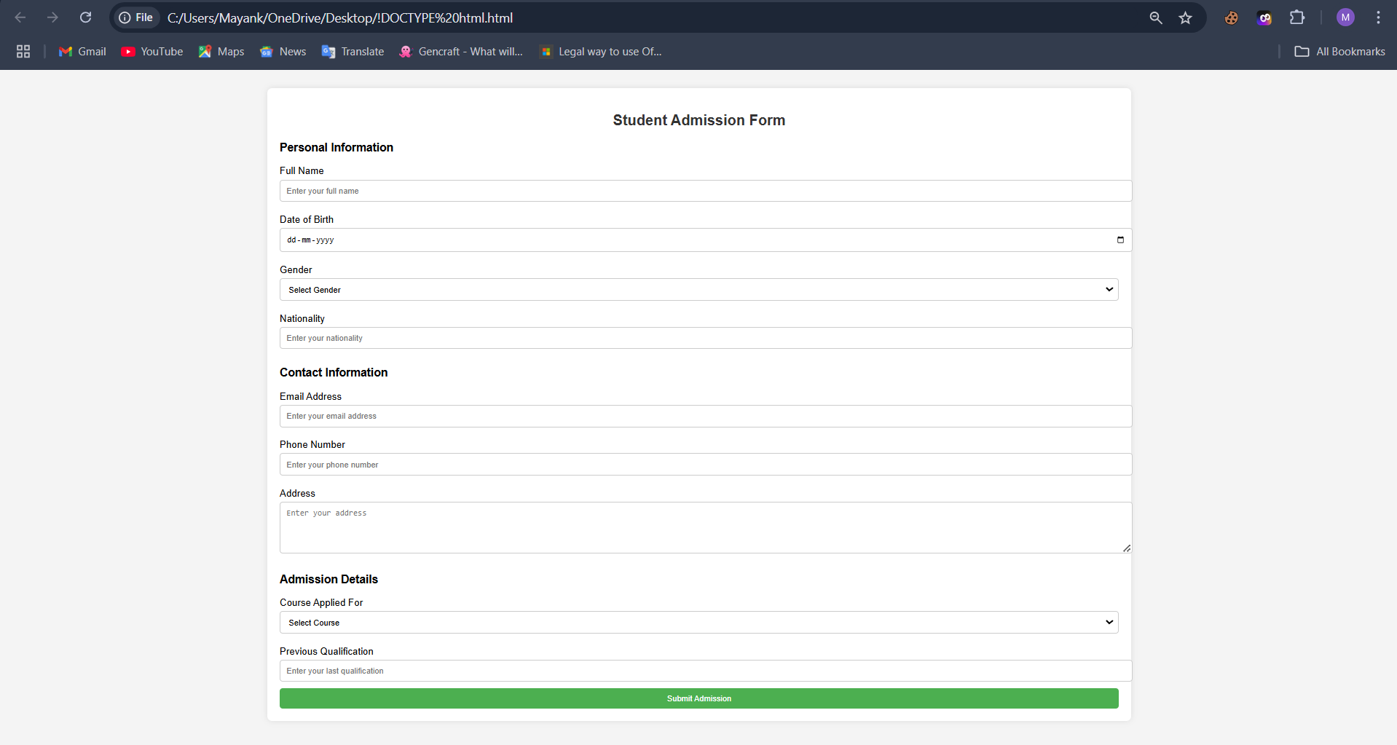

Exercise – 20&25

Write HTML code to design a student admission Form in HTML.

Write code to show Internal CSS with HTML code.

HTML Code:

<!DOCTYPE html>

<html lang="en">

<head>

<meta charset="UTF-8">

<meta name="viewport" content="width=device-width, initial-scale=1.0">

<title>My Home Page</title>

<style>

body { font-family: Arial, sans-serif; margin: 0; padding: 0; }

header, nav, footer { background-color: #333; color: white; text-align: center; padding: 10px 0; }

nav a { color: white; margin: 0 10px; text-decoration: none; }

main { padding: 20px; text-align: center; }

footer { font-size: 0.8em; }

</style>

</head>

<body>

<header>

<h1>Welcome to My Website</h1>

<p>Your one-stop destination for web development tips and tutorials.</p>

</header>

<nav>

<a href="#home">Home</a>

<a href="#about">About</a>

<a href="#services">Services</a>

<a href="#contact">Contact</a>

</nav>

<main>

<section id="home">

<h2>Home</h2>

<p>This is the homepage where you'll find the latest updates and featured content.</p>

</section>

<section id="about">

<h2>About Me</h2>

<p>I am a passionate web developer sharing insights on the latest web trends and technologies.</p>

</section>

<section id="services">

<h2>Services</h2>

<p>Offering web design, development, and SEO services to help your website stand out.</p>

</section>

<section id="contact">

<h2>Contact</h2>

<p>Feel free to reach out through my email: contact@mywebsite.com</p>

</section>

</main>

<footer>

<p>&copy; 2024 My Website. All Rights Reserved.</p>

</footer>

</body>

</html>

Output:

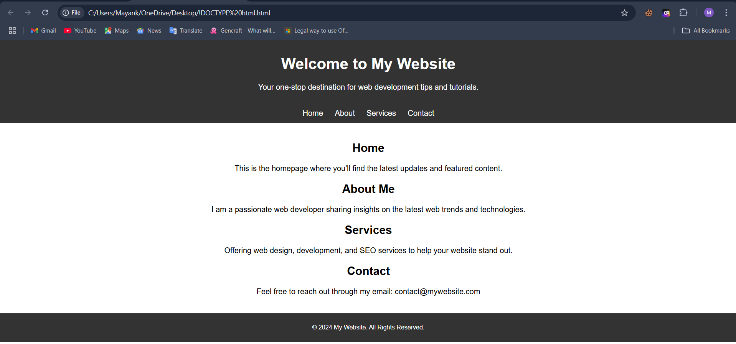

Exercise – 21 , 22 & 23

Write HTML code for including Inter hyperlinking in a web page.

Write HTML code for including Inter hyperlinking in a web page.

Write HTML code for including External hyperlinking in a web page.

HTML Code:

<!DOCTYPE html>

<html lang="en">

<head>

<meta charset="UTF-8">

<meta name="viewport" content="width=device-width, initial-scale=1.0">

<title>Hyperlinking Example</title>

<link rel="stylesheet" href="styles.css">

</head>

<body>

<header>

<h1>Welcome to My Web Page</h1>

<p>Click the links below to navigate within the page, to another page within the site, or to an external website.</p>

</header>

<nav>

<ul>

<li><a href="#section1">Go to Section 1 (Local)</a></li>

<li><a href="#section2">Go to Section 2 (Local)</a></li>

<li><a href="about.html">Go to About Us (Internal)</a></li>

<li><a href="https://www.example.com" target="_blank">Visit Example Website (External)</a></li>

</ul>

</nav>

</body>

</html>

CSS Code:

* {

margin: 0;

padding: 0;

box-sizing: border-box;

}

body {

font-family: Arial, sans-serif;

line-height: 1.6;

background-color: #f4f4f4;

color: #333;

padding: 20px;

}

header {

text-align: center;

margin-bottom: 20px;

}

header h1 {

font-size: 2.5em;

color: #4CAF50;

}

header p {

font-size: 1.2em;

color: #555;

}

nav ul {

list-style-type: none;

text-align: center;

margin-bottom: 30px;

}

nav ul li {

display: inline;

margin-right: 20px;

}

nav ul li a {

text-decoration: none;

color: #007BFF;

font-size: 1.2em;

}

nav ul li a:hover {

color: #0056b3;

text-decoration: underline;

}

Output:

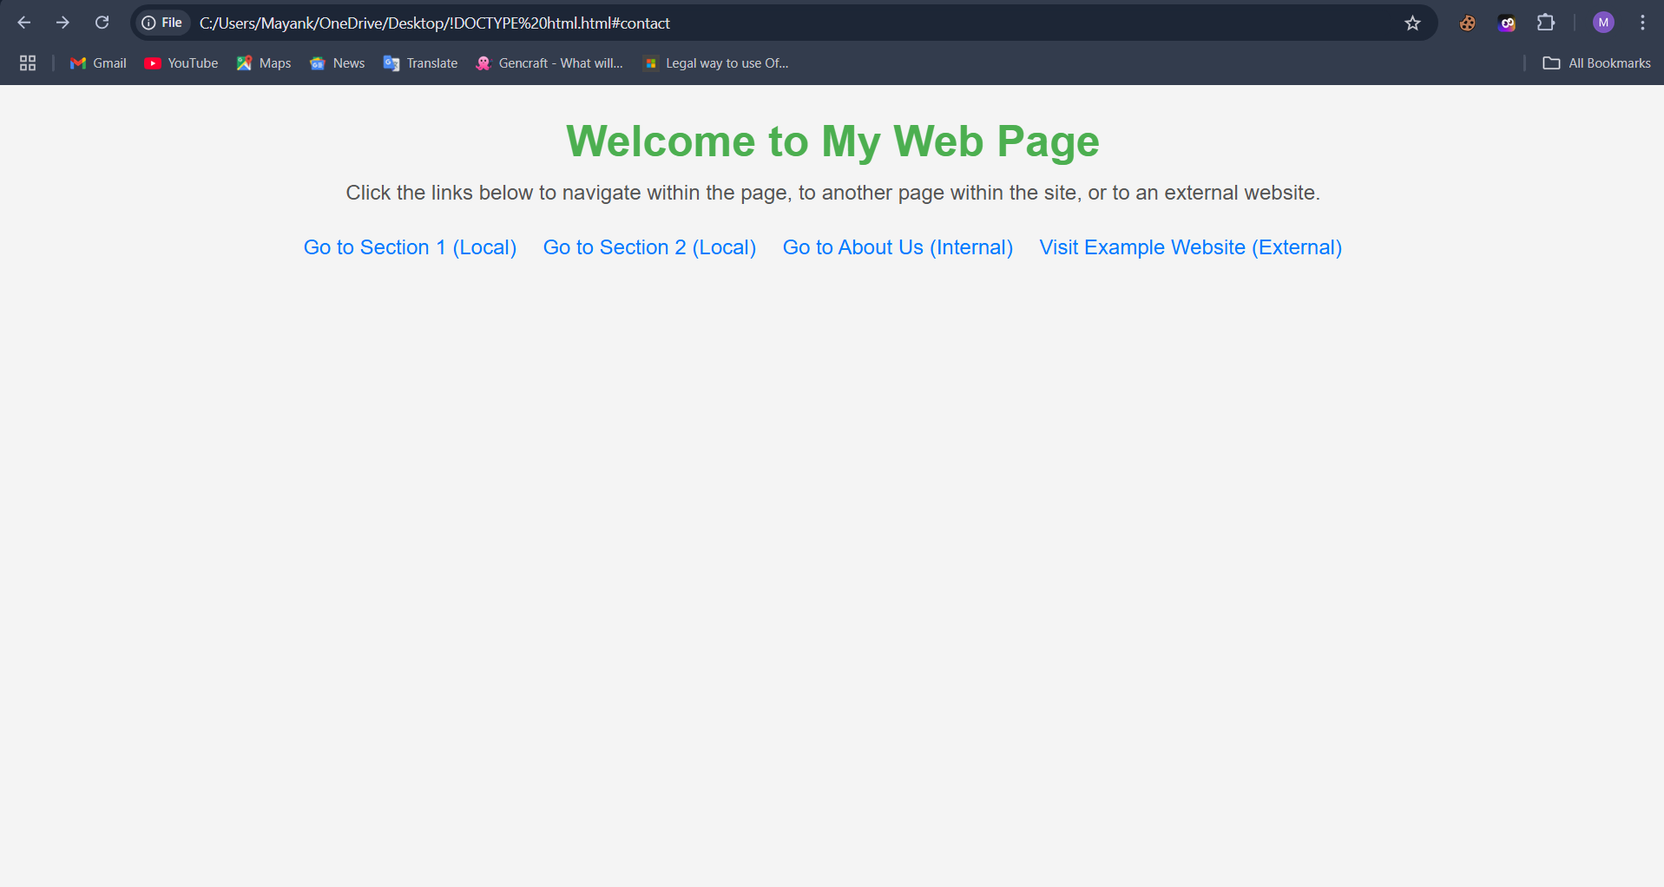

Exercise – 26

Write code to show Inline CSS with HTML code

Code:

<!DOCTYPE html>

<html lang="en">

<head>

<meta charset="UTF-8">

<meta name="viewport" content="width=device-width, initial-scale=1.0">

<title>Inline CSS Example</title>

</head>

<body>

<h1 style="color: blue; text-align: center;">Welcome to My Website</h1>

<p style="font-size: 18px; color: gray;">

This is a sample paragraph styled with inline CSS. Inline CSS allows you to add styles directly to individual elements.

</p>

<button style="background-color: green; color: white; padding: 10px 20px; border: none; cursor: pointer;">

Click Me

</button>

</body>

</html>

Output:

